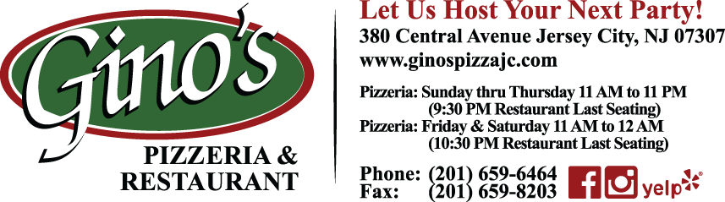

Option 1: Side Salad
Choice of Pasta Sauce
Vodka or Tomato
Choice of Entrée:
Chicken Parmigiana, Chicken Francese, Chicken Marsala or Chicken Sorrentino
Veal Parmigiana, Veal Francese or Veal Marsala
Eggplant Parmigiana or Eggplant Rollatini
Filet Oreganata

$24.95 per person
Option 2: Add Bruschetta
$28.95 per person
Option 3: Add Hot Antipasto

$34.95 per person

***All Options come with Soda, Coffee & Tea***

Drink Options

Beer & Wine
$25.00 per person

House Liquor
$30.00 per person

Premium Liquor
$50.00 per person

**Gratuity and Taxes NOT included

