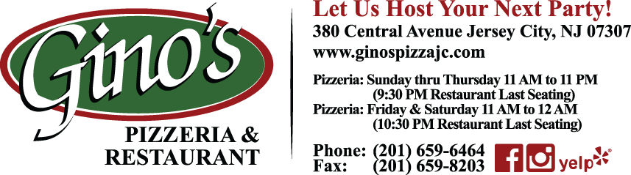

OFF SITE CATERING MENU
***PICK UP OR DROP OFF ONLY WITHIN DELIVERY ZONES***
***NO SET-UP OR SERVERS PROVIDED***

Half Tray Full Tray

8-10 Servings 12-15 Servings

Chicken Parmigiana Chicken Breast Breaded & Baked with Tomato Sauce & Mozzarella $ 45.00 $ 85.00
Chicken Francese Chicken Breast Batter Dipped & Sautéed in a White Wine Lemon Sauce $ 55.00 $100.00
Chicken Marsala Chicken Breast Sautéed with Mushrooms in a Marsala Wine Sauce $ 55.00 $100.00
Chicken Montebianco Chicken Breast Topped w/ Spinach & Mozzarella in a Cognac Cream Demi $ 75.00 $140.00
Eggplant Parmigiana Eggplant Breaded & Baked with Tomato Sauce & Mozzarella $ 35.00 $ 60.00
Eggplant Rollentini Eggplant Filled with Seasoned Ricotta & Baked with Tomato Sauce & Mozzarella $ 40.00 $ 70.00
Veal Parmigiana Veal Cutlets Breaded & Baked with Tomato Sauce & Mozzarella $ 65.00 $120.00
Veal Francese Veal Cutlets Batter Dipped & Sautéed in a White Wine Lemon Sauce $ 65.00 $120.00
Veal Marsala Veal Cutlets Sautéed with Mushrooms in a Marsala Wine Sauce $ 65.00 $120.00
Shrimp Parmigiana Shrimp Breaded & Baked with Tomato Sauce & Mozzarella $ 90.00 $175.00
Shrimp Scampi Sautéed with Olive Oil, Garlic, White Wine & Touch of Tomato Sauce $100.00 $200.00
Shrimp Fra Diavlo Spicy Tomato Sauce $100.00 $200.00
Ziti with Tomato Sauce $ 25.00 $ 45.00
Ziti with Marinara Sauce $ 25.00 $ 45.00
Ziti with Vodka Sauce $ 35.00 $ 60.00
Cavatelli & Broccoli $ 35.00 $ 60.00
Baked Ziti $ 30.00 $ 55.00
Stuffed Shells $ 40.00 $ 70.00
Baked Manicotti $ 40.00 $ 70.00
Lasagna $ 50.00 $ 95.00
Baked Clams $ 55.00 $105.00
Filet Oreganato Sole Filet Topped with Olive Oil, Garlic & Bread Crumbs $ 75.00 $140.00
Roasted Potatoes & Vegetables $ 30.00 $ 50.00
Meatballs $ 40.00 $ 70.00
Stuffed Mushrooms Filled with Seasoned Bread Crumbs $ 40.00 $ 70.00
Sausage, Peppers & Potatoes $ 40.00 $ 70.00
Tossed Salad Dressing Choices: Caesar, Ranch, Honey Mustard, Balsamic Vinaigrette, French, Russian $ 20.00 $ 35.00
Caesar Salad $ 25.00 $ 45.00
6 Foot Sub Sandwich Ham, Salami, Provolone, Lettuce, Tomato, Onion, Mayo, Oil & Vinegar 30-35 Servings $125.00
Please Specify Roll with or without Seeds, Condiments Also Available on the Side
2-Liter Soda Pepsi, Diet Pepsi, Sierra Mist, Ginger Ale & Assorted Flavors $ 2.50 each

***TRAYS: PLEASE PLACE ORDERS AT LEAST 24 HOURS IN ADVANCE***
***SIX FOOT SUBS: PLEASE PLACE ORDERS AT LEAST 48 HOURS IN ADVANCE***
For Additional Menu Items Not Listed Above or Special Dietary Requests
Please Consult with Gino’s Friendly Staff

